**DAY 4**

**BUILDING DYNAMIC FRONTEND COMPONENTS**

**FOR YOUR MARKETPLACE**

1. Product Listing Component / VS Code:

The Product Listing Page is the Primary interface where users can view all products.

**Product Listing Page**

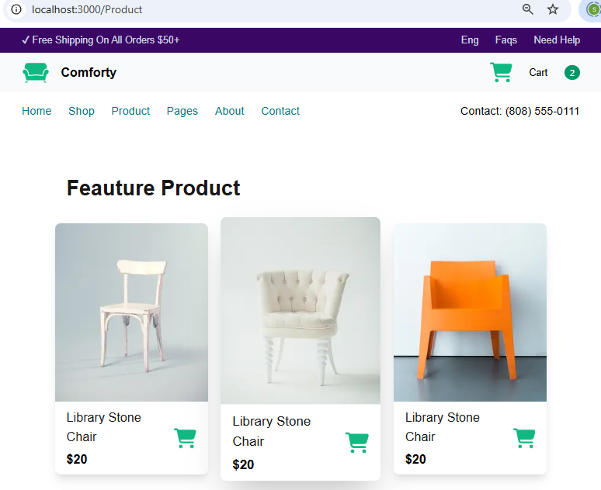

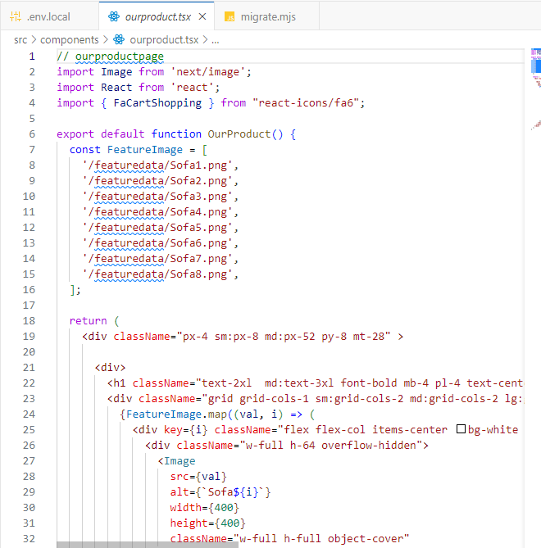

Cart Functionality

The Cart Functionality manages the user selected items to shopping experience by their choice and rates.

